**North County Courthouse – Attending a Hearing**

Address: 325 South Melrose Drive, Vista, CA 92081

Business Office Hours: Monday – Friday, 8:30am – 4pm

There is typically plenty of parking, although it may be difficult to find a parking spot close to the entrance. At the Vista Courthouse you will see that there are two different entrances. It will be easiest for you to enter through the entrance labeled “San Diego Superior Court North Entrance,” which has a painted design above the doorway.

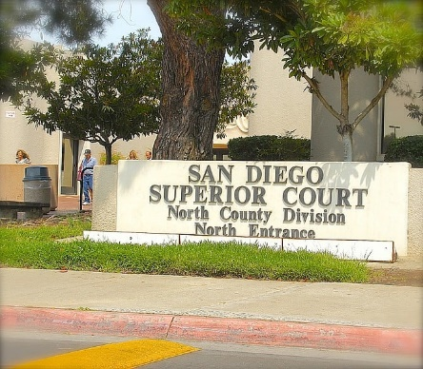

Be sure to wear your CASA badge. As you enter the building, you will go through security and make sure you do not have anything on your person that could be construed as a weapon or it will be confiscated. Once you have gotten through security, make a right and walk down the hallway, then make a left down the first hallway and Department N4 will be all the way at the end on the right. Please check in with the court officer, they typically come out into the hallway after 8:30 to check in the parties.

After checking in with everyone, you can wait in the courtroom or outside in the waiting area with your case child(ren). If you forgot or do not have your CASA badge, our case liaison can provide you with a temporary sticker.

When your hearing is called, sit at the table towards the right hand side near your youth and/or their attorney. When addressing the judge, please stand and refer to the judge as “Your Honor.”

***Please bring your own supplies, including pen and paper and bottled water. Food and drinks are not allowed in the courtroom, but the bailiff is comfortable with CASAs and VFC staff bringing in bottled water.

If you are appearing on MS teams, please let your supervisor know so they can inform the courtroom clerk, the minors’ attorneys, and the CL in the courtroom.